Multiliteracies Project
EDUC5256 – English Teachable
Natalie Hogeterp, Kaitlyn Drake, Brennen Siemens,
Lila Ezwawi, Morgan Lawrence, Alexa Mognon
October 25, 2023

Lesson Plan:
Subject/Course: ENG3U | Names: Kaitlyn Drake, Lila Ezwawi, Natalie Hogeterp, Morgan Lawrence, and Brennen Siemens
Grade Level: Grade 11 | Date & Time: October 26th, 2023 – 10:30AM
Topic: Descriptive Language in Poetry | Length of Lesson: 75 minutes

CURRICULUM EXPECTATION(S)

Overall Expectations: Media Studies

- Understanding Media Forms, Conventions, and Techniques: identify some media forms and explain how the conventions and techniques associated with them are used to create meaning.

- Creating Media Texts: create a variety of media texts for different purposes and audiences, using appropriate forms, conventions, and techniques.

Specific Expectation(s):

2.2 identify conventions and/or techniques used in a variety of media forms and explain how they convey meaning and influence their audience.

3.2 select a media form to suit the topic, purpose, and audience for a media text they plan to create and explain why it is a highly appropriate choice.

3.3 identify a variety of conventions and/or techniques appropriate to a media form they plan to use and explain how these will help communicate a specific aspect of their intended meaning effectively.

Learning Goal(s)/Refined Expectations(s):

Students will…

- Be able to identify descriptive language and literary techniques such as imagery, metaphor, etc.
- Explain why these literary techniques convey meaning to their audience.
- Use these techniques effectively in their own writing/work.

Success Criteria:
I will…
- Use descriptive language and literary techniques such as imagery, metaphors, and personification to describe my interpretations of the poems.
- Understand various thoughts regarding poetry and why poems convey different meanings to different people.
- Express myself through artistic and written portions of the poetry analysis assignment.
ASSESSMENT/EVALUATION
Curriculum
Strategy: Creative writing assignment, media analysis Recording Device: Rubric
Learning Skills
Skill(s): Independent work, responsibility, critical analysis Recording Device: Observation
DIVERSITY AND INCLUSIVITY

For the assignment, students will be able to explore their own interpretations of the artwork/poem through a visual collage. This can include personal views and thoughts that stem from their own perceptions of the world around them, incorporating elements pertaining to individual identity such as ethnicity, sexual orientation, religion, socioeconomic status, etc.

This lesson will cover an abundance of learning styles to accommodate for students in the class who learn visually, audially, and kinesthetically.
- Visual: Students will draw or jot annotations on the first poem during the first fifteen minutes of class; the formative assessment being conducted in the form of a visual collage will allow visual learners to display their ideas and thoughts in a manner that suits their learning style. Physical copies of the poems will help facilitate the learning environment.
- Audial: Students will listen to the first poem during the first fifteen minutes of class.
- Kinesthetic: The hands-on assignment that students will complete incorporates a kinesthetic style by forming a visually crafted collage using various materials.

For hard of hearing or visually impaired students, the physical copies of poems and musical piece will accommodate.
LEARNING ENVIRONMENT (Physical Space)

Students will be seated in columns for this class as the majority of the work will be independent and involve students’ individual feelings and emotions in regard to the paintings/poems. Students will be tasked with explaining and visualizing how the poems and art makes them feel, therefore they need to focus individually without distractions.

RESOURCES AND MATERIALS
- An Autumn Evening by Lucy Maud Montgomery https://mypoeticside.com/show-classic-poem-19782
- An Autumn Evening worksheet for Minds on
- “Olive Orchard” by Vincent Van Gogh https://www.youtube.com/watch?v=Pg09EMepZ2c
- A Day in the Open by Lucy Maud Montgomery https://mypoeticside.com/show-classic-poem-19763
- Analyzing Poetry infographic https://www.canva.com/design/DAFyS3HuK2M/8SdrYg9k5bUwHLLaai5xIA/edit?utm_content=DAFyS3HuK2M&utm_campaign=designshare&utm_medium=link2&utm_source=sharebutton
- “What is Descriptive Language?” infographic.
- Collage Assignment Rubric
- Collage materials (if physical copy): magazines, paint, brushes, stickers, letters.
- Example: https://www.canva.com/design/DAFyUtMRnp4/7fr3SUldJCuDdv3--SoiJA/edit?utm_content=DAFyUtMRnp4&utm_campaign=designshare&utm_medium=link2&utm_source=sharebutton

Description of Pedagogical Tool:
The pedagogical tools used are infographics that explain how to analyze poetry and what is involved when using descriptive language. Infographics incorporate both written and visual aids that students of all learning styles can access as prompts while they are engaging in the classroom.
The Pedagogical Tool: Infographics:
The first infographic discusses analyzing poetry. The second infographic discusses descriptive language.

TEACHING/LEARNING SEQUENCE
Beginning/Activation: 15 min

The beginning hook will introduce students to poetry in two short activities; these will allow students to begin thinking about how various art forms facilitate greater creative thinking.

The teacher will read the poem An Autumn Evening by Lucy Maud Montgomery to the class. Each student will receive a photocopy of the poem. As students are listening to the poem, they will draw and write in the margins of the poem, imagery, colors and feelings that emerged from their interpretation of the poem.

This first activity demonstrates how evocative language in poetry translates into a variety of visual and emotional conveyances. It will help students begin to think about how written poetry can be translated into a visual collage format.

An Autumn Evening by Lucy Maud Montgomery
https://mypoeticside.com/show-classic-poem-19782
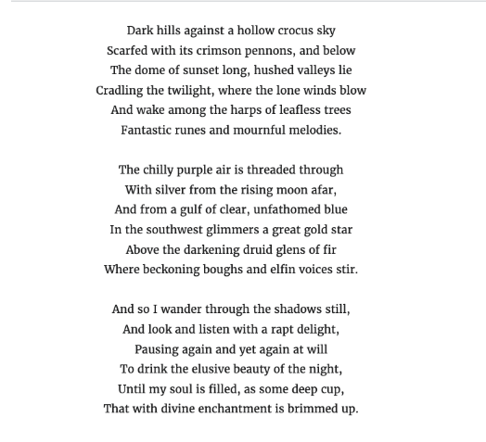

Middle/Action/Application/Exploration: 25 min

The second activity will have the teacher present students with the painting “Olive Orchard” by Vincent Van Gogh created in 1889 on the board. They will share the musical piece created by the University of Northern Iowa Wind Ensemble, conducted by Danny Galyen, which was created through inspiration of the painting. Students will receive a blank piece of printer paper. As they are listening to the music, students will write down how they think the music and painting connect to each other.

This activity demonstrates to students how various art forms, in this case music and painting, can interact with each other. This mind-on activity will help students begin to think about how written poetry can be translated into a visual collage format and help transition the lesson into the assignment.

https://www.youtube.com/watch?v=Pg09EMepZ2c

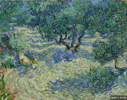

COLLAGE ASSIGNMENT POEM

Students will be given a handout of the poem, A Day in the Open by Lucy Maud Montgomery. Utilizing the evocative language in the poem, students will create a visual collage using magazine/newspaper cut outs or through an online platform like Canva. This project is a subjective creative expression of a student's individual interpretation of written poetry.

After creating this collage, students will write a one – two-page explanation of the rationale using descriptive language using elements from the infographic.

https://mypoeticside.com/show-classic-poem-19763

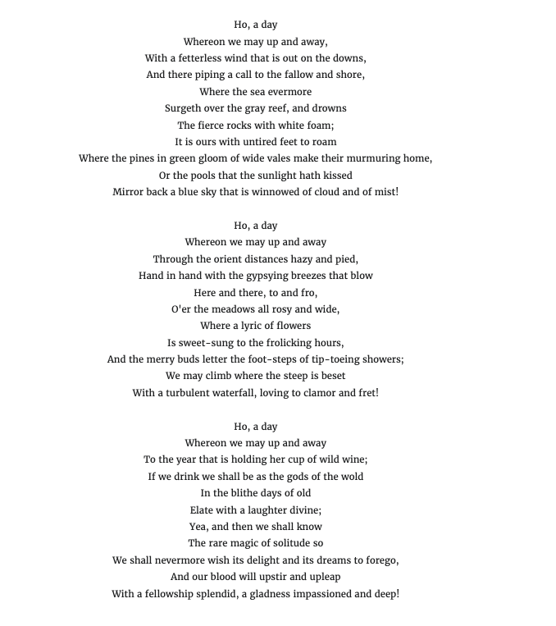

End/Consolidation/Communication: 35 min
Students will be given the rest of the class time to work on their collages for their assignment. They need time in class to choose between a physical and digital format, create ideas for their collage, and have time to read/listen to the poem.
NEXT STEPS:
By learning about descriptive language with regard to poetry analysis, students will be tasked with the 1-2 page write up rationale about their collages. They are to use descriptive language to identify their interpretation of the poem and hand this write-up in with their collage.

Resources
Worksheet:
https://docs.google.com/document/d/156kC3UhRLcnHb6pcPxLs2011U3cmpvnWc8D9U6AmEYE/edit

Rubric:

Sample Collage for student reference: An Autumn Evening

