**Translating Written Poetry into a Creative Visual Expression**

**Please read the poem below, making notes in the margins of imagery, colours or emotions that emerge. Create a visual collage that represents what this poem means to you!**

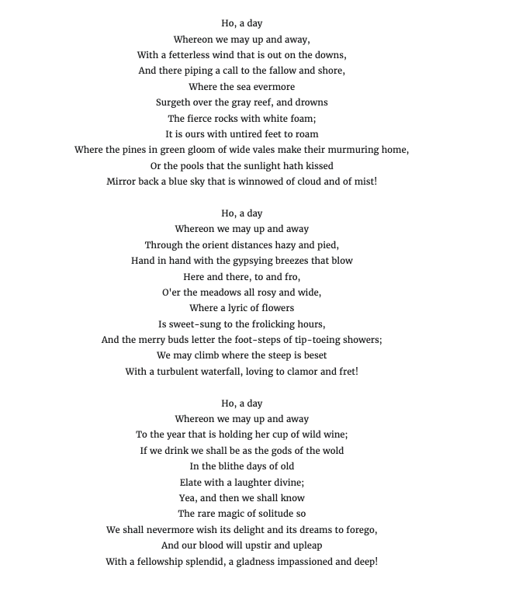

**Checklist:**

* I have read the poem and made notes analyzing the evocative language and meaning of work.
* Using a 8x10 I have used magazines, newspapers and online images to create a collage representing my interpretation of the poem
* My collage displays a variety of ideas
* I have written a one-two page double spaced rationale, explaining how my collage relates to the poem.
* My rationale is detailed and well organized

**Rubric:**

| **Assessment:** | **Level 1** | **Level 2** | **Level 3** | **Level 4** |
| --- | --- | --- | --- | --- |
| **THINKING %15**  Students will be evaluated on their ability to recognize evocative language in written poetry. | Student does not recognize evocative language | Student somewhat recognizes evocative language | Student meets expectations recognizes  evocative language | Students excels at recognizing evocative language |
| **APPLICATION %20**  Students will be assessed on their ability to apply knowledge of language analysis in a visual format. | Student does not apply knowledge of of language analysis in a visual format | Student partially applies knowledge of of language analysis in a visual format | Student meets expectations in applying knowledge of language analysis in a visual format | Student excels at applying knowledge of language analysis in a visual format |
| **COMMUNICATION %15**  Students collage communicates their interpretation of the poem and written explanation explains students rationale | Student’s collage does not communicate their interpretation of the poem and written explanation explains students rationale | Student communicate their interpretation of the poem very little in their collage and written explanation | Student communicate their interpretation of the poem and written explanation explains students rationale well | Student communicates their interpretation of the poem and written explanation explains students rationale very well |
| **KNOWLEDGE %20**  Students will be assessed on their ability to demonstrate critical thinking in their poem analysis, collage creation and written rationale | Student shows little ability to demonstrate critical thinking in their poem analysis, collage creation and written rationale | Student somewhat demonstrates ability to critical thinking in their poem analysis, collage creation and written rationale | Student meets expectations in to critical thinking in their poem analysis, collage creation and written rationale | Student excels in critical thinking in their poem analysis, collage creation and written rationale |