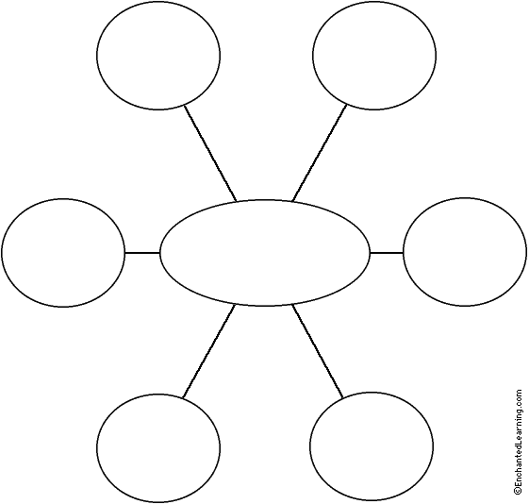
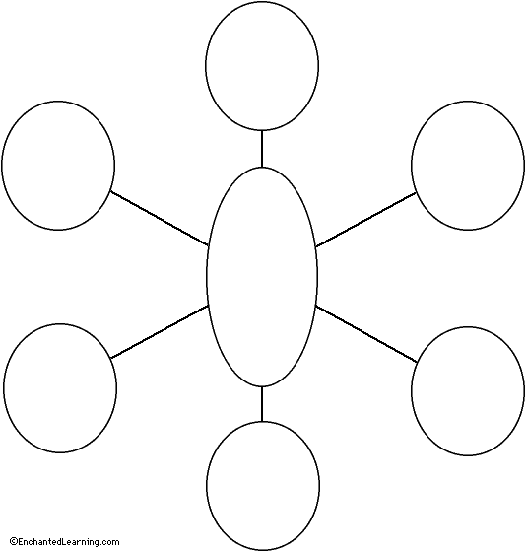
System Components
Respiratory Word Web
Instructions:
Using your notebooks and worksheets as a guide, fill in the word web bubbles with terms relating to the center words.
Factors Affecting Breathing
Types of Volumes
and Capacities

